- Join us! Try out [CLASS] on [DATE] at [TIME], [LOCATION] for free! #UnitedWeSweat
- Come out and enjoy a free [Class] class at [TIME] on [DATE] at [LOCATION]! #UnitedWeSweat @UHAvonFitness @LorainCCC @LorainCountyMetroParks @LorainCountyHealth @UWLorainCounty
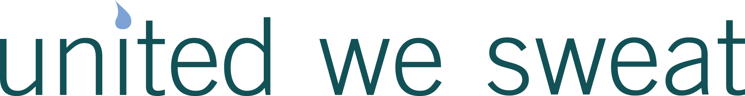
- Have you ever wanted to try [CLASS]? Come out and try it for free at [LOCATION] at [TIME]! #UnitedWeSweat
- In a slump? Come spice up your routine with a free [CLASS] class at [TIME] on [DATE] at [LOCATION]. #UnitedWeSweat
- Bring a friend to a free [CLASS] at [TIME] on [DATE] at [LOCATION]! #UnitedWeSweat
- Happy hour that actually makes you happy. Come increase endorphins (feel-good hormones) with us for free on [DATE] [TIME]. #UnitedWeSweat
- Free [CLASS] at [TIME] at [LOCATION] with [BUSINESS] #UnitedWeSweat
- You deserve some time for you. Try out [CLASS] on [DATE] at [TIME], [LOCATION] for free! #UnitedWeSweat
- Free fitness events across Lorain County! Check out the free classes we’re offering this month at UnitedWeSweat.org #UnitedWeSweat

